Software Firewall

🧰 What is a Software Firewall?
# Source: AI Source: Provided by: [Data Path: Persons Table -> ID Column: 1, Name_En Column: Motasem Essam] -> From: [ChatGPT] on [12/18/2025]
A Software Firewall is a program or application installed on a computer, server, or device that monitors, filters, and controls incoming and outgoing network traffic based on security rules. It helps protect individual systems from unauthorized access and threats.
✅ Think of it as a personal security guard that watches what goes in and out of a specific device.

🧠 What It Does
# Source: AI Source: Provided by: [Data Path: Persons Table -> ID Column: 1, Name_En Column: Motasem Essam] -> From: [ChatGPT] on [12/18/2025]
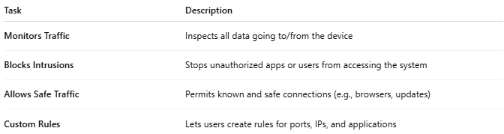

Task | Description
Monitors Traffic | Inspects all data going to/from the device
Blocks Intrusions | Stops unauthorized apps or users from accessing the system
Allows Safe Traffic | Permits known and safe connections (e.g., browsers, updates)
Custom Rules | Lets users create rules for ports, IPs, and applications

🖥️ Where It’s Used
# Source: AI Source: Provided by: [Data Path: Persons Table -> ID Column: 1, Name_En Column: Motasem Essam] -> From: [ChatGPT] on [12/18/2025]
- Laptops and desktops (e.g., Windows, macOS, Linux)
- Servers (web, email, database)
- Mobile devices (with built-in or third-party firewalls)
- Virtual machines or containers

🆚 Software vs Hardware Firewall
# Source: AI Source: Provided by: [Data Path: Persons Table -> ID Column: 1, Name_En Column: Motasem Essam] -> From: [ChatGPT] on [12/18/2025]
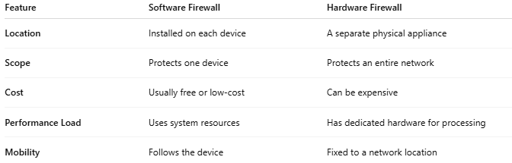

Feature | Software Firewall | Hardware Firewall
Location | Installed on each device | A separate physical appliance
Scope | Protects one device | Protects an entire network
Cost | Usually free or low-cost | Can be expensive
Performance Load | Uses system resources | Has dedicated hardware for processing
Mobility | Follows the device | Fixed to a network location

🔧 Examples of Software Firewalls
# Source: AI Source: Provided by: [Data Path: Persons Table -> ID Column: 1, Name_En Column: Motasem Essam] -> From: [ChatGPT] on [12/18/2025]
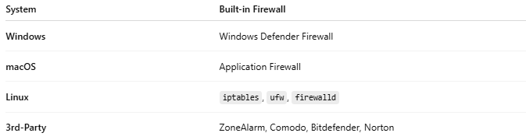

System | Built-in Firewall
Windows | Windows Defender Firewall
macOS | Application Firewall
Linux | iptables, ufw, firewalld
3rd-Party | ZoneAlarm, Comodo, Bitdefender, Norton

✅ Pros
# Source: AI Source: Provided by: [Data Path: Persons Table -> ID Column: 1, Name_En Column: Motasem Essam] -> From: [ChatGPT] on [12/18/2025]
- ✅ Easy to install and configure
- ✅ Granular control over individual applications
- ✅ Often built into operating systems
- ✅ Free or low-cost options available
- ✅ Moves with the device (great for laptops/mobile)

❌ Cons
# Source: AI Source: Provided by: [Data Path: Persons Table -> ID Column: 1, Name_En Column: Motasem Essam] -> From: [ChatGPT] on [12/18/2025]
- ❌ Protects only one device
- ❌ Can slow down system performance
- ❌ May be bypassed by malware if not properly secured
- ❌ Not sufficient for enterprise-scale security on its own

🛡️ Common Features
# Source: AI Source: Provided by: [Data Path: Persons Table -> ID Column: 1, Name_En Column: Motasem Essam] -> From: [ChatGPT] on [12/18/2025]
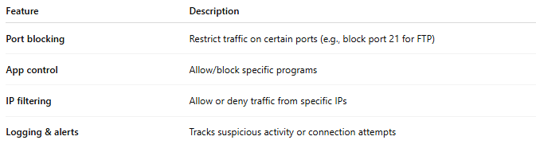

Feature | Description
Port blocking | Restrict traffic on certain ports (e.g., block port 21 for FTP)
App control | Allow/block specific programs
IP filtering | Allow or deny traffic from specific IPs
Logging & alerts | Tracks suspicious activity or connection attempts

📌 Summary
# Source: AI Source: Provided by: [Data Path: Persons Table -> ID Column: 1, Name_En Column: Motasem Essam] -> From: [ChatGPT] on [12/18/2025]
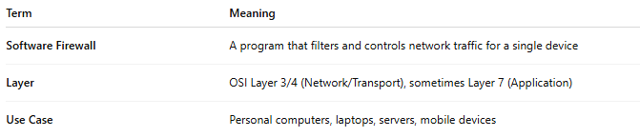

Term | Meaning
Software Firewall | A program that filters and controls network traffic for a single device
Layer | OSI Layer 3/4 (Network/Transport), sometimes Layer 7 (Application)
Use Case | Personal computers, laptops, servers, mobile devices

